How to Update Your Personal Information (online)

Log-in to your account at [www.yourbenefitaccount.net/pensioninc/](http://www.yourbenefitaccount.net/pensioninc/) or [www.pensioninc.net](http://www.pensioninc.net)

From the Dashboard Summary > Select Settings Gear Icon in Top Right Corner

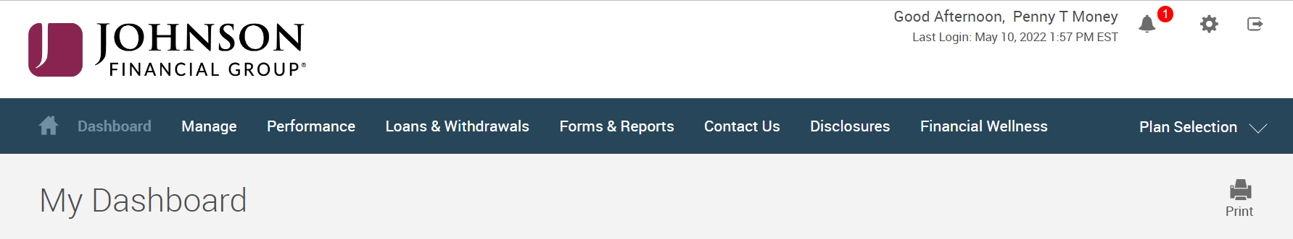

From Drop Down Menu > Select Personal Info

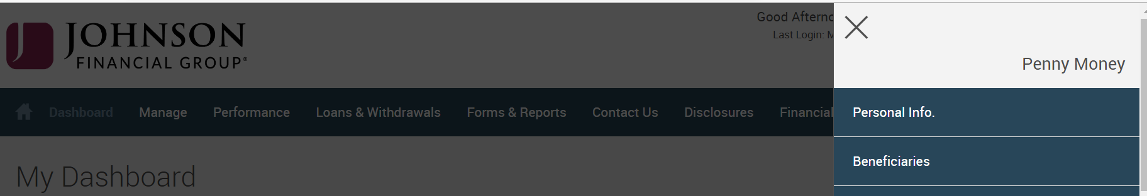

Edit Personal Information > Click **Each** Arrow to Verify/Update Demographic Information > Click Submit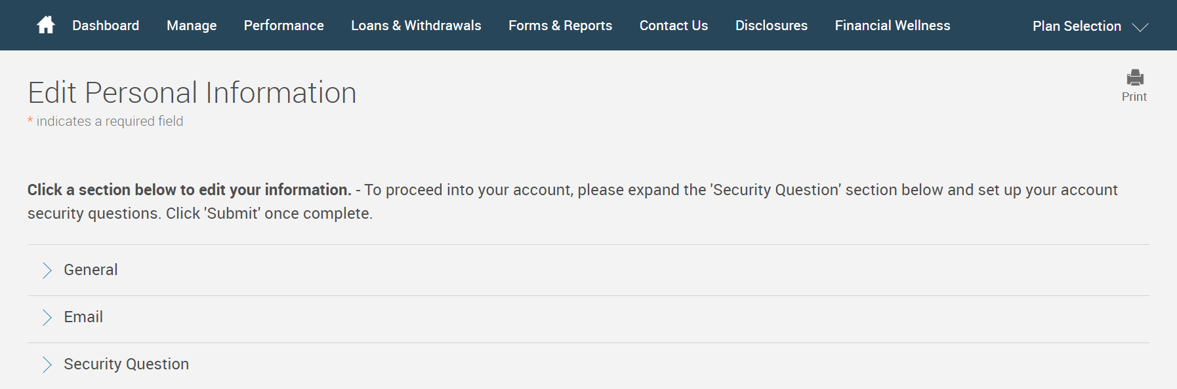

You will receive a GREEN Confirmation Code

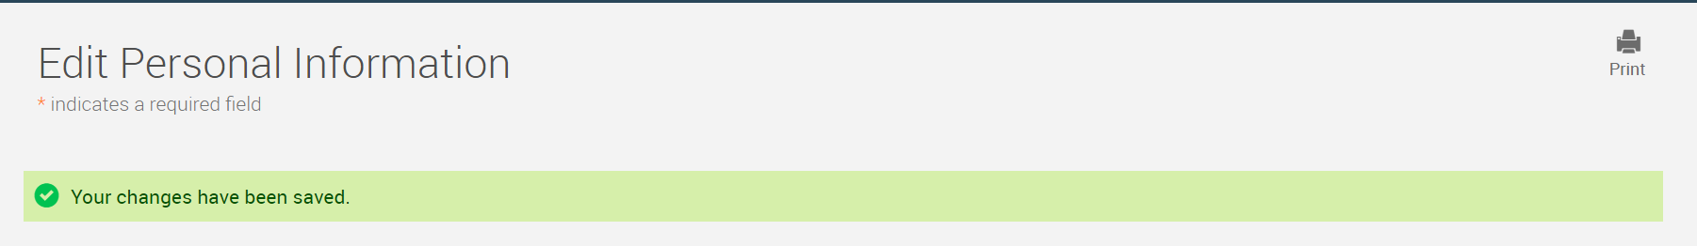

All changes require an overnight cycle to appear online and will be processed as soon as administratively feasible in accordance with your plan provisions.

*Read Summary Plan Description (located in Forms) for more information*

*Please contact the Participant Support Center at 1.920.432.7020 or 1.877.865.7899 with any questions*